|  |
| --- |
| **INTERIM REPORT  FOR THE**  **TECHCONTROL WEB INFORMATION SYSTEM** |
| Andrej Roth K181080  Amarpreet Singh K170242  Rohan Jaswal K180583  Amolak Singh K190689 |

# Project Overview

## Introduction

TechControl is a Slovakian business specialising in installation and servicing of home security systems such as alarms, surveillance and access controls. At the moment their web presence is limited. They are looking to establish an e-commerce system and start selling the products online with the option of onsite installation.

## Purpose

The purpose of this project is to develop a dynamic web information system, that will serve as an e-commerce store for Techcontrol. Being able to sell directly to the customers will give the Techcontrol a competitive advantage and opens a new space for growth. Using the new web information system, they will be able to provide a full service, from purchase to the installation and maintenance of the products, and improve interaction with existing and potential customers.

# Project Scope

## Description

This project will consist of creating an e-commerce system, that will be accessible over the internet, using any browser. The system must be secure and user friendly. The project will be completed by 4th October 2020. Users will be able to browse through the e-commerce site, add items to the shopping cart and make a purchase.

## Deliverables

* Prototype Design
* Project Report
* Account and login information
* Fully Functional E-commerce System
  + Graphical User Interface
  + Application
  + Database
* A backup copy of the files
* Staff Training
* Support Documentation

## Constraints

* The budget of this project is $10,000 AUD.
* The system will be developed by 27th September 2020.

## Assumptions

* TechControl will cover the costs of the project.
* Project will be concluded after evaluation on 4th October 2020.

# Milestones

|  |  |  |
| --- | --- | --- |
| **Milestone Name** | **Milestone Description** | **Milestone Date** |
| Milestone 1 – Project Definition | Group is formed and tasks are discussed internally. | 20/03/2020 |
| Milestone 2 - Project Scope | Planning and outlining the project activities and deliverables are finished. Interim Project Report is Submitted | 20/04/2020 |
| Milestone 3 – Project Analysis | The requirements are gathered and the site architecture is discussed | 02/05/2020 |
| Milestone 4 – Project Design | Database, interface, and software are designed and the diagrams are finalized. The Final Project Report is submitted to the supervisor | 22/05/2020 |
| Milestone 5 – System Development | Database, Graphical user interface, and application are developed and coded. | 13/09/2020 |
| Milestone 6 – System Testing | Before the system gets implemented, it must be tested to identify and rectify issues | 27/09/2020 |
| Milestone 7 – System Implementation | The system is implemented and launched | 02/10/2020 |

# Work Breakdown Structure

# C:\Users\rahul\Downloads\WhatsApp Image 2020-04-19 at 20.01.34.jpeg

# Project Timeline

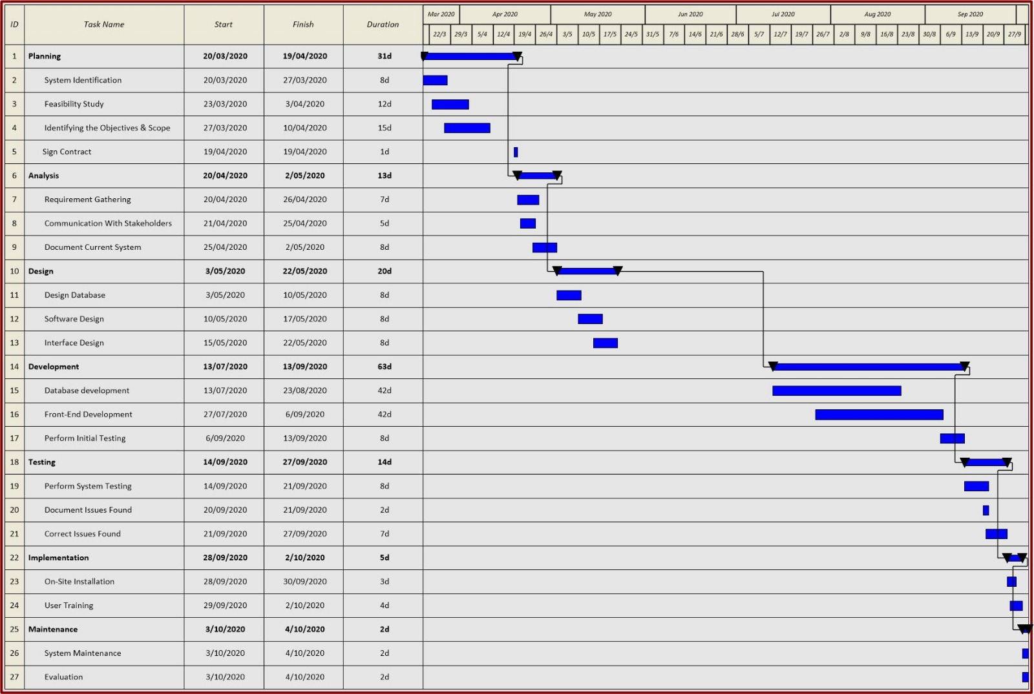

# Supervisor’s Feedback

|  |  |
| --- | --- |
| **Supervisor Feedback** | **Team response** |
| Supervisor reached out to the team leader via email, to introduce other team members. | Team leader has contacted other team members via email and scheduled a meeting to discuss the project. |
| Supervisor advised to collaborate on the Github | Team has agreed, established Github presence, formed a team and created a project repository for further collaboration. |
| Supervisor has advised scheduling the tasks on Github. | Team leader has allocated tasks to each team member and set a deadline for each task. |
| **Supervisor reviewed or report draft and suggested the following adjustments:** |  |
| Update scope statement, and include a detailed description of key deliverables | Task has been assigned to Amolak, to work on key deliverables part of the report which will be included under scope statement. |
| Create a Gantt chart | Team leader has created the Gantt chart in Microsoft Project and inserted it into the report. |
|  |  |